Follow Me Eyes Installation Instructions

These are instructions to attach the Follow Me Eyes (eye sclera) to the mask.

You will need Scissors and Hot Glue.

| 1. Cut the felt in thirds at the dotted line in the picture. (See **Reference Image 1b**) | **Reference Image 1b** |
| --- | --- |
| 1. Glue the felt to the back of the eye top and bottom of the eye sclera. Leave half the felt hanging off.  (See **Reference Image 2b**) | **Reference Image 2b** |
| 1. Line up the eye sclera to the head base. Glue the felt to the head base from the inside. (See **Reference Image 3b**)   Use the remaining felt, to attach the nose. | **Reference Image 3b** |

If you have issues, please feel free to message me at my etsy shop 3DPrintTherapyShop, or email [3DPrintTherapyShop@gmail.com](mailto:3DPrintTherapyShop@gmail.com).

Eye Mesh Installation Instructions

This was not in the original listing, but I have included a free eye mesh inside your order! The paper has instructions on how to attach them to the eye sclera.

You will need Scissors and Hot Glue.

| 1. Cut the eye mesh in half at the dotted line in the picture. (See **Reference Image 1a**) | **Reference Image 1a** |
| --- | --- |
| 1. You should now have two square eye mesh. (See **Reference Image 2a**) | **Reference Image 2a** |
| 1. Glue Masks to the back of the follow me eyes. (See **Reference Image 3a**)  Trim off the excess eye mesh if needed. | **Reference Image 3a** |

If you have issues, please feel free to message me at my etsy shop 3DPrintTherapyShop, or email 3DPrintTherapyShop@gmail.com.

How to tie the elastic (Polar Bear)

Instructions: (see reference image 1, step number relate to the image numbers)

1. This hole is for the elastic strap, that holds the mask to the head
2. For “articulated jaws”, tie the last two jaw holes to the hole below the elastic strap
3. Tie the holes at this location for a “talk jaw”

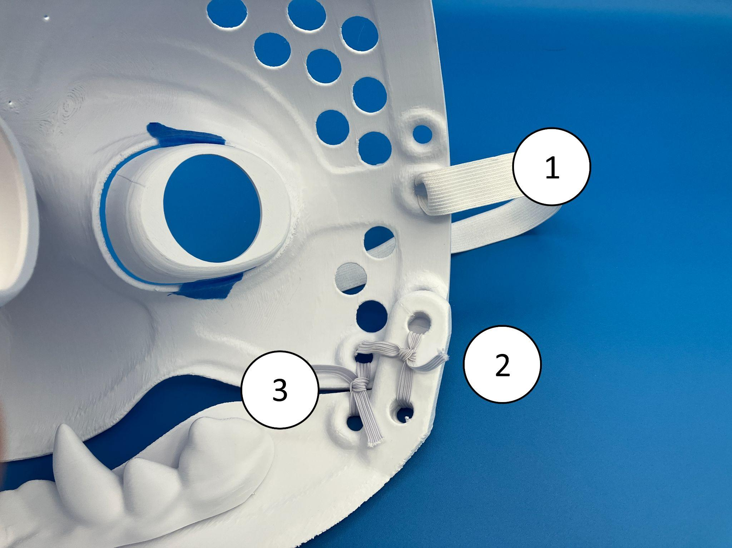

Reference Image 1

If you have issues, please feel free to message me at my etsy shop 3DPrintTherapyShop, or email 3DPrintTherapyShop@gmail.com.